Ezkylle Opiniano 02/03/2026
NW – 301 6BLOCKTECH
Midterm Lab Quiz 1: Service Fees and Generating Unique Hash Value
EVEN Units (PC) only
Develop a Solidity smart contract that calculates a total service fee and generates a unique hash value based on specific input parameters(sample data).
First name: Jose
Middle Name: Balsa
Last name: Rizal
Service code: [1 or 2 ]
**1 : Consultation = 20,000 plus 15% tax
**2: Documents = 3,000 plus 8% service charge plus 15% tax
Service Fee:
Hash Generation requirements:
Message format = last character of the first name, first character of the middle name, last character of the Lastname, service code, first digit of the service fee
Service code =1 use abi.encode
Service code =2 use abi.encodePacked
Deploy the contract using first account of the ganche if the service code = 1
Deploy the contract using your MetaMask main account is the service code = 2.

Provide clear, high-resolution screenshots of the following:
- Wallet Balances: Your Ganache or MetaMask account before and after deployment to show the gas deduction.
- Contract Execution: The Remix (or IDE) console showing the calculated Service Fee and the resulting Hash Value.

Code:
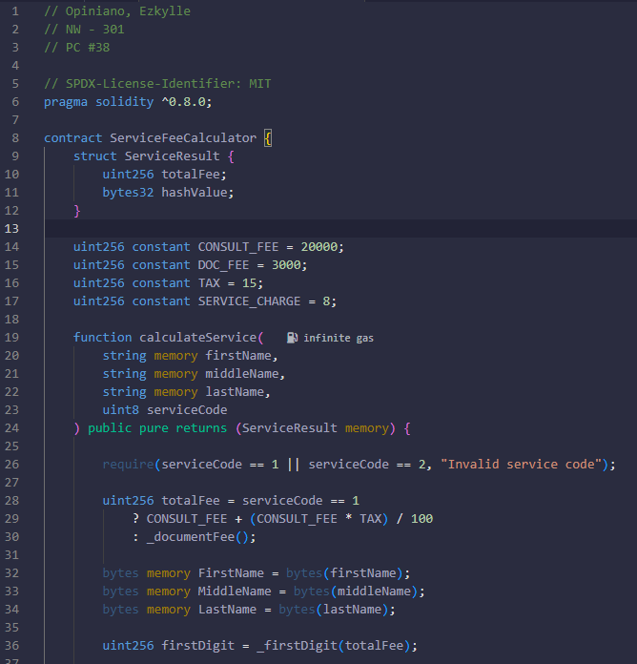
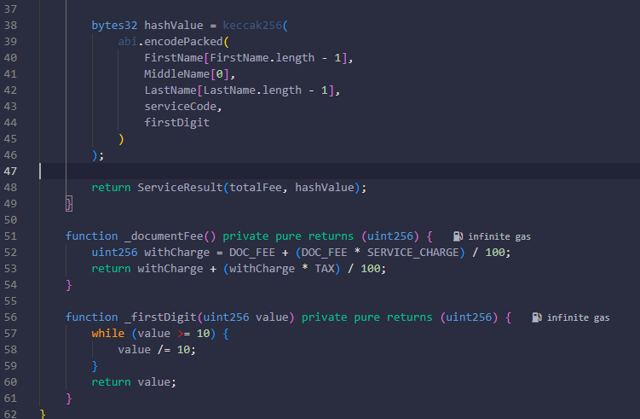

Screenshot:
Before: Deploying the contract service code 1 on ganache wallet
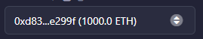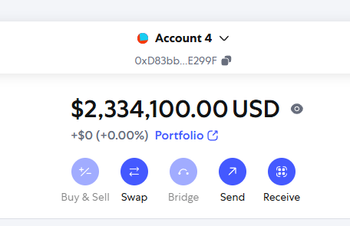
After:
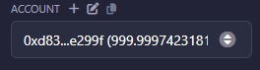
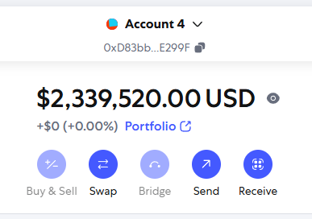
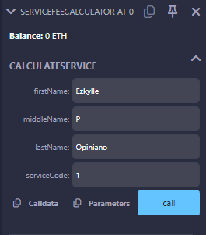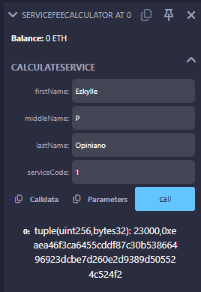
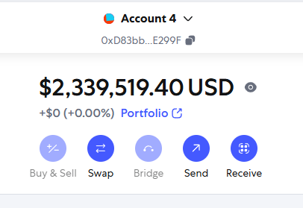
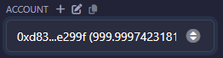

Before: Deploying the contract service code 2 on MetaMask wallet 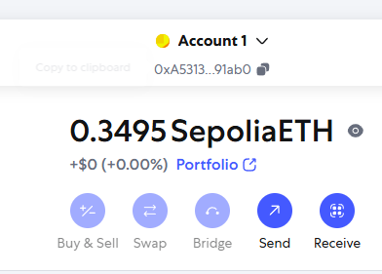 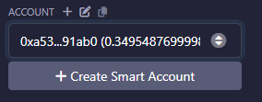
After:
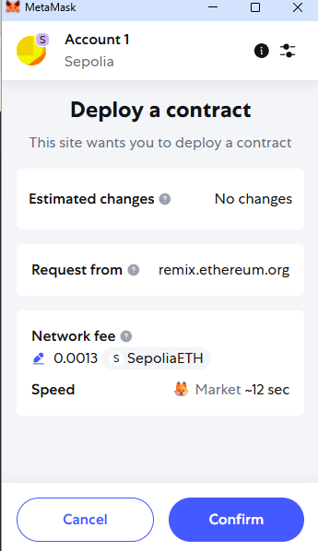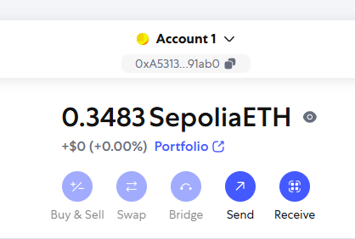
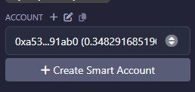

After input:
